**All Under One Sky 2025**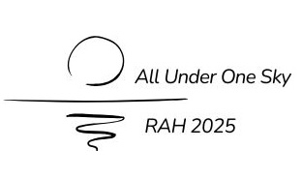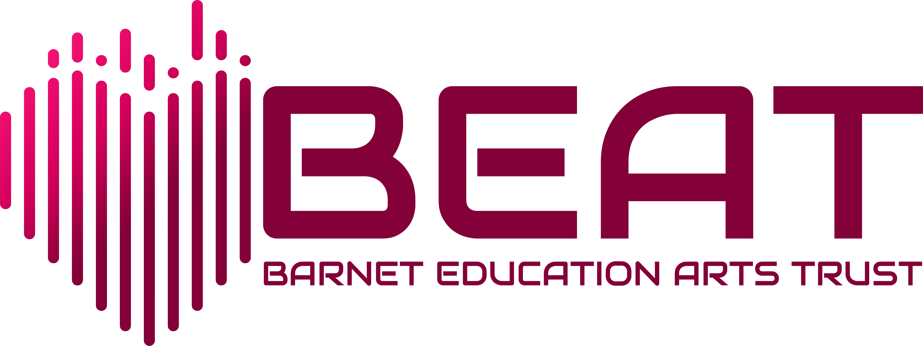

**Information for the Royal Albert Hall BOPA licence**

* **Name of school:** Click or tap here to enter text.

**THE INFORMATION WE NEED AND WHY WE NEED IT**

* Because the concert involves children performing at a licensed venue in front of a paying audience, they come under legislation designed to protect child performers; this legislation is not primarily aimed at educational events like ours, but we need to ensure we are compliant with the law.
* We will be applying for a **Body of Persons Approval** licence - this licenses us to run the events rather than licensing children individually.
* Normally a BOPA licence would mean we would be asked to collect and hold information relevant to safeguarding for all the children concerned – specifically names, addresses, ages, and medical information, as well as DBS numbers for the adults looking after those children. Because of the way our events work, it is understood that schools take responsibility for their children on the day, and that they should be responsible for this information, much of which is sensitive personal data.
* However, we do need summary information to help ensure we organise the event properly.

***It is important that you answer the questions below knowing who is going to attend on the day. Please do not estimate numbers. We need this summary information in advance as a condition of our license.***

* **Total number of children** **performing**: Click or tap here to enter text.

*Please note that children must be aged 9 or over on the day of the concert.*

* **Are all of these children resident in Barnet?** YES *If yes, go on to the next section.*

*If no, please say how many children are not resident in Barnet and which local authority or authorities they are resident in. We may need to contact you about this.*

Click or tap here to enter text.

* **Medical information**

*Please pass on relevant medical information concerning these children. You do not need to name individual children* (eg. one child with asthma, staff to carry named inhaler).

Click or tap here to enter text.

* **Number of accompanying adults** Click or tap here to enter text.

**I confirm that the above summary information about the children attending the Royal Albert Hall Concert is correct and that we will inform BEAT of any subsequent changes. I confirm that accompanying adults have been checked in line with school safeguarding policies (including up to date DBS checks for all staff and policies to ensure proper supervision of other adult helpers), and that supervising adults will have access to that personal information about the children which is necessary to ensure proper safeguarding at the event.**

Signature: Date:

Name: Email:

**Please email this form to** [sharon.broughall@beatrust.org.uk](mailto:sharon.broughall@beatrust.org.uk) **by Monday 9th December 2024**